**Tender Document**

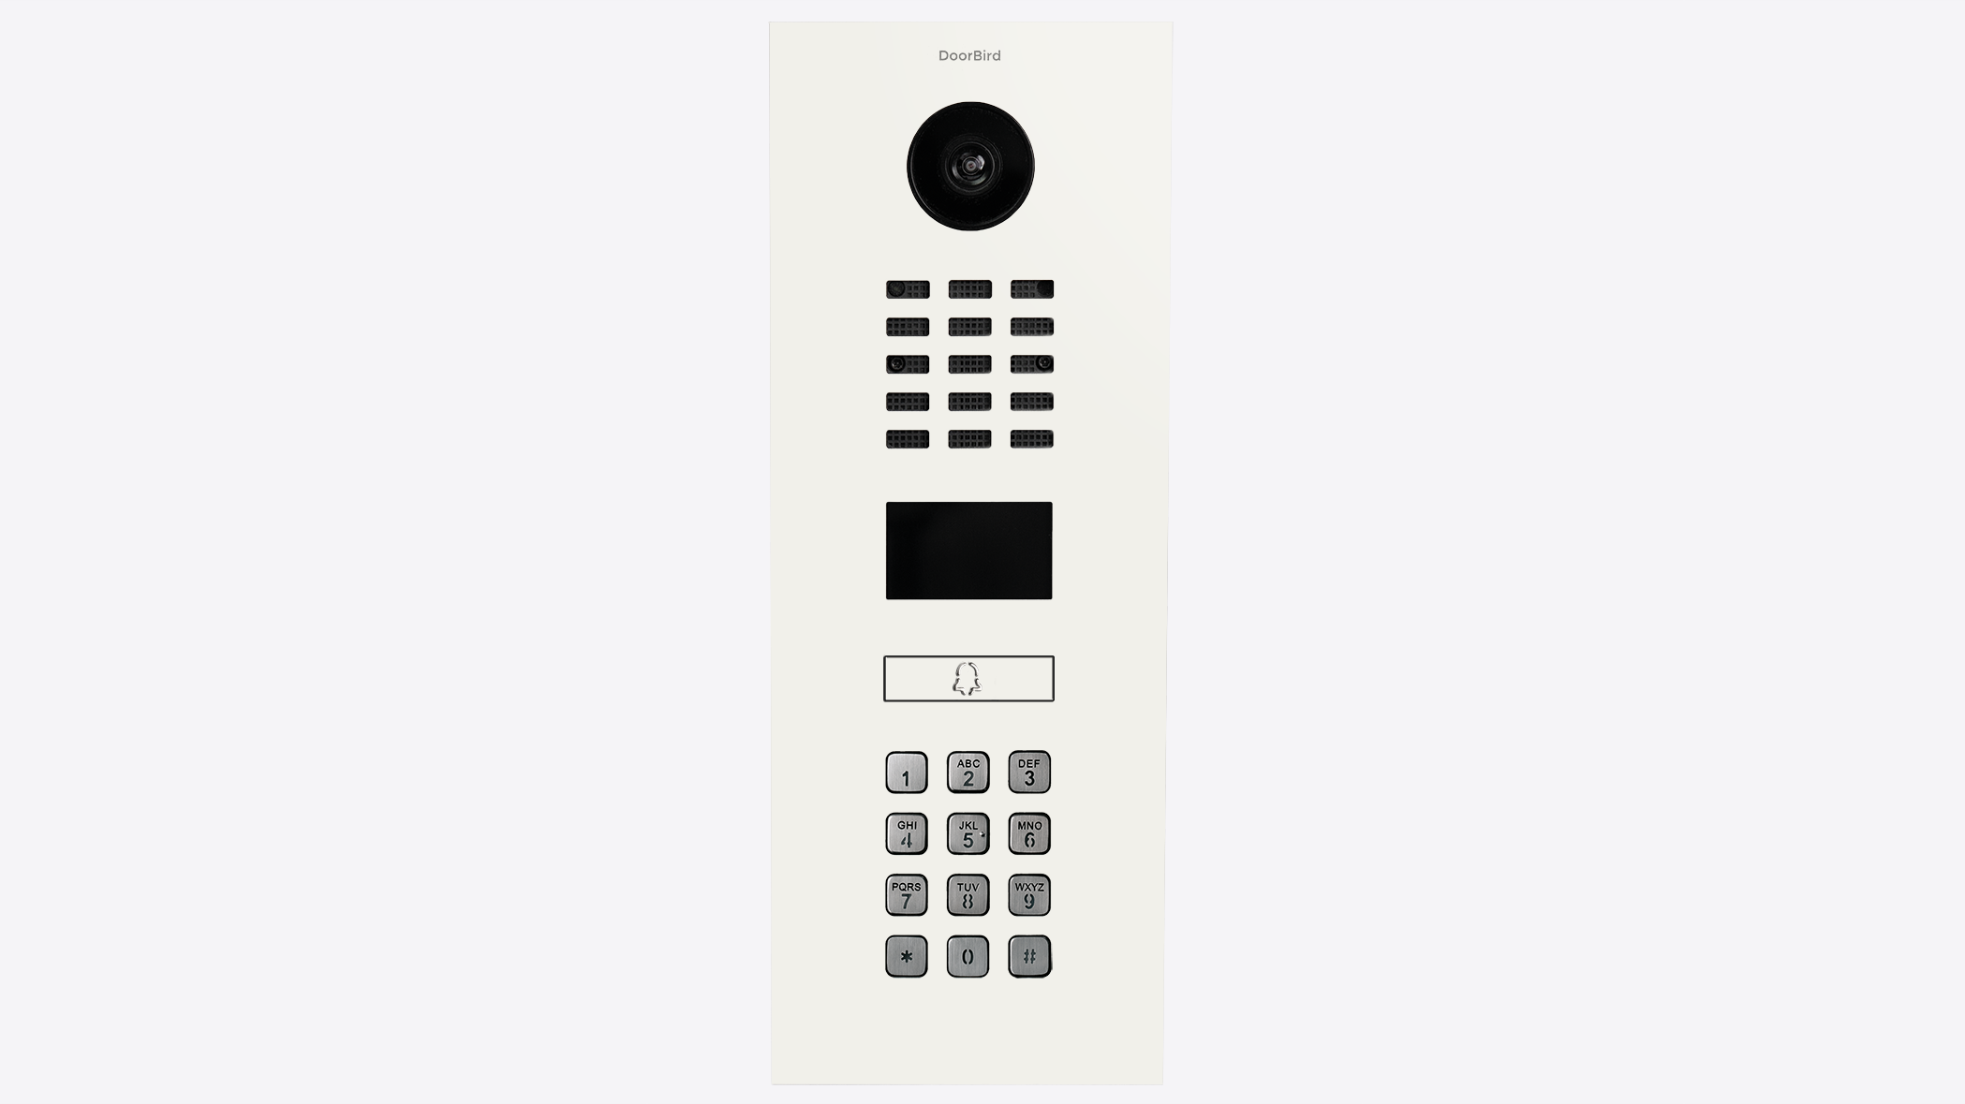

**Product Name**

D2101KV IP Video Intercom

**Short Description**

Intercom system for single-family homes and businesses with 1 unit, 1 call button

**Product Description**

* Surface- and flush-mount possible, housings sold separately
* LAN connection (PoE capable)
* 2-way audio
* Ultra-wide angle lens, 720p, night vision, 12 IR LEDs
* 4D motion sensor, RFID reader
* Keypad
* Intercom with 2 freely configurable bistable switching relays

**Highlights and Details**

* Open API Local interface for integration with third-party systems and SIP
* Video and audio call On smartphones, tablets (iOS, Android), IP and landline phones (SIP)
* Smart Transmission Mode (STM) Real-time audio / video communication, optimized for mobile devices via WiFi, 3G, 4G, 5G
* Smart Home & NVR compatible Control4, Loxone, Crestron, Synology, AVM FRITZ!Fon, URC, QNAP, RTI, ELAN, Fibaro, Bang & Olufsen and others
* Automatic door buzzer For use in medical offices and office environments
* Free visitor history Store still images for free, optional video recording available
* Individual action schedules, e.g.: RFID card “abc” has only access on Wednesday from 9 am until 11 am 4D motion sensor switches on external lamp between 9 pm and 6 am
* Geofencing Automatic door and gate opening when returning home
* Night vision With 12 Infrared LEDs
* HDTV Video Ultra wide-angle, hemispheric lens, 180°
* Light sensor For night vision mode
* Microphone Video intercom with clear voice transmission
* Noise reduction and echo cancellation (AEC, ANR)
* RFID reader Configurable remotely via App (e.g. time frame)
* Motion sensor with 4D technology Distance up to 10 m (32.8 ft) adjustable via App (interval: 1 m/ 3.3 ft)
* Call button With backlit nameplate
* Easy connection of the intercom to the network Connection via a network cable or bell wire via 2-Wire Ethernet PoE Converter “DooBird A1071” (PoE, network data)
* Two freely configurable bi-stable switching relays Two doors or gates can be controlled via App Status configurable via App: temporary or permanent circuit
* Keypad Module Configurable via App More than 500 individual PIN codes Individual events (e.g. trigger a relay, HTTP(s) request)

**Product Weight**

2620 gm

**Delivery time**

Delivery within 30 business days!

**Datasheet**

[datasheet_d2101kv_02_en.pdf (doorbird.com)](https://doorbird.com/downloads/datasheet/datasheet_d2101kv_02_en.pdf)